<Insert Capability> Deployment Guide
DevOps CI/CD Pipeline Design Document

Contents
1 Guide Document Control 3
1.1 Stakeholders 3
1.2 Amendment Record 3
2 Introduction 4
2.1 Purpose 4
3 Architecture 5
3.1 Logical Architecture 5
4 Hardware Sizing 6
5 CI/CD Pipeline in Non-Production Environment 7
5.1Introduction…………………………………………………………………………………………………… 7
5.2 Different Stages in Pipeline……………………………………………………………………………………7
5.3 Unit Test Stage…………………………………………………………………………………………………7
5.4 SonarQube Stage………………………………………………………………………………………….…10
5.5 Build Stage…………………………………………………………………………………………………….13
5.6 Deployment Stage…………………………………………………………………………………………….13
5.6.1 Containerized Apps…………………………………………………………………………………….13
5.6.2 Non-Containerized Apps………………………………………………………………………………14
5.7 Build Pipeline Flow…………………………………………………………………………………………...15
5.8 Existing Pipelines……………………………………………………………………………………………..16
6 CI/CD Pipeline in Production Environment 17
7 FlowChart for Pipeline Process 18
8 Pipeline as a Code Concept………………………………………………………………...……19
8.1 Introduction…………………………………………………………………………………………19
8.2 Jenkinsfile…………………………………………………………………………………………..19
9 Appendix 24
9.1 Reference Links 24

Guide Document Control

Stakeholders
The individuals who reviewed, verified, and approved the content of this document based on the requirements of the defined services during this document’s creation are listed in the table below:
Table 1. Stakeholders
Name | Job Role

Amendment Record
The following Change History log contains a record of changes made to this document:
Table 2. Change History
Published / Revised Date | Version # | Section /  Nature of Change

Introduction
A CI/CD Pipeline automates your software delivery process.The pipeline builds code, run tests(CI) and safely deploys a new version of the application(CD).

Purpose

In today’s competitive world, organizations cannot wait for more time and based on manual effort to deploy/deliver their applications.
With CI, each change in code triggers an automated build-and-test sequence for the given project,
providing feedback to the developer(s) who made the change. The entire CI feedback loop should run in less than 10 minutes.
Continuous Delivery includes infrastructure provisioning and deployment,
which may be manual and consist of multiple stages.
What’s important is that all these processes are fully automated, with each run fully logged and visible to the entire team.

Architecture

Logical Architecture

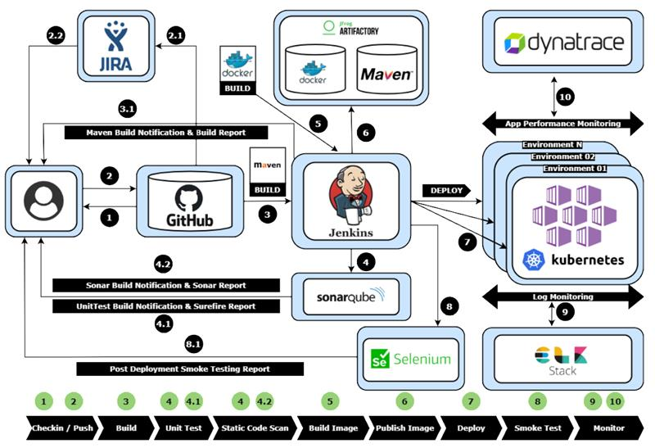

Hardware Sizing

Jenkins
Hostname | Size | Storage | IP address | Username | Password | Function
MDCAzSLMJKLV01  (Ubuntu Machine) | Standard_A8m_v2 | 500 | 10.16.26.51 | appadmin |  | Jenkins

SonarQube
Hostname | Size | Storage | IP address | Username | Password | Function
MDCAzSLMJKLV01  (Ubuntu Machine) |  |  | 10.16.26.51 | appadmin |  | SonarQube

CI/CD Pipeline in Non-Production Environment

Introduction

If you come to CI/CD Pipeline, we have divided the Pipeline into two parts:
1.Non-Prod Pipeline
2 Prod Pipeline
This Non-Prod Pipeline will cover all the environments upto Pre-Prod and Prod Pipeline is only specific for Production environment.
The Non-Prod pipeline should be a single pipeline which deploys upto Pre-Prod. But right now we are having different pipelines for different environments even till pre-prod which will be a similar pipeline for all the environments like Dev and TSB in place right now.

Different stages in Pipeline
In a common CI/CD pipeline,there should be multiple stages which will run a complete pipeline.
If you take our CI/CD Pipeline which is already in place in our Jenkins contains Four different stages.
The four stages are like below:
1. Unit Test
2. SonarQube Analysis
3. Building
4. Deployment

5.3 Unit Test Stage:
Unit test stage is nothing but a Jenkins job which will take the code and running Unit test cases by using Junit and npm for Java and nodejs apps respectively.
After running the unit test cases, Jenkins will publish those test results and it will generate a HTML Unit test report.
Jenkins will automatically send these UnitTest Reports to Respective Developers.
If this UnitTest stage passes then only the CI/CD pipeline moves to the next stage.
If this stage fail then Jenkins will abort the pipeline and send the build failure notification to the team.

Steps to Create Unit Test Job in Jenkins:

- 1.Create New Item and select “Free Style Project”, Provide the name click OK
- In “General Section” Provide the description and select the checkbox if any details required else ignore
- Under “Source Code Management Section” Select the Git and provide the URL of your Code Repository

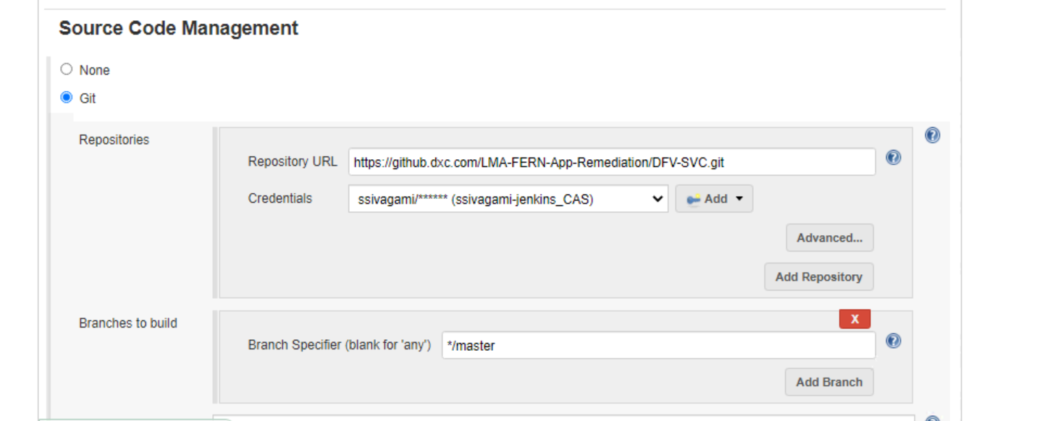

- Under “Build Triggers” please select the Appropriate build trigger type.
  - Build after other projects are built: You can trigger this job after other projects are ran.
  - Build periodically: You can specify the timings so that it will run periodically, irrespective of code commit changes
  - GitHub hook trigger for GIT SCM polling: You can use Git Webhook feature to trigger the job by Posting Query to Jenkins URL when commits happens to Repo
  - Poll SCM: Specify the duration so that it will check the repo for new commits, if there are new commits it will trigger the job.

- Under “Build Section” Select the “invoke top level Maven targets” and choose the Maven you configured in initial maven installation under configure system
  - In Goals you write “clean test” ///it will compile the Code written in Java and it generates target/surefire-reports/*.xml file which can used later in next step to provide some User Interface Junit Results
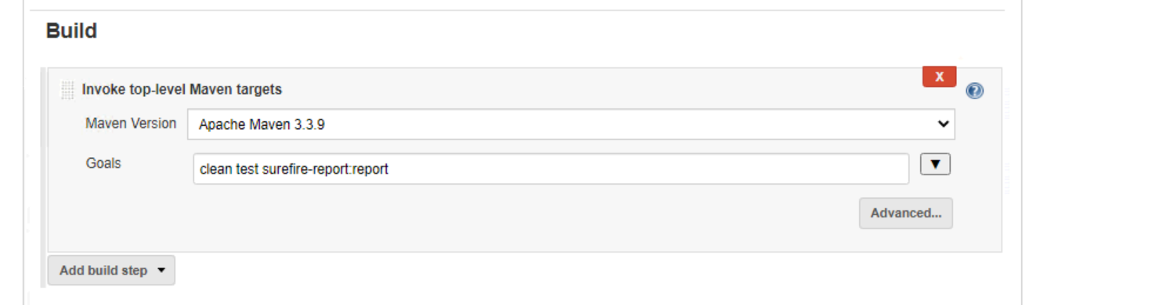

- Under “Post Build Actions” choose Publish Junit test result report results and provide the Path of the File.
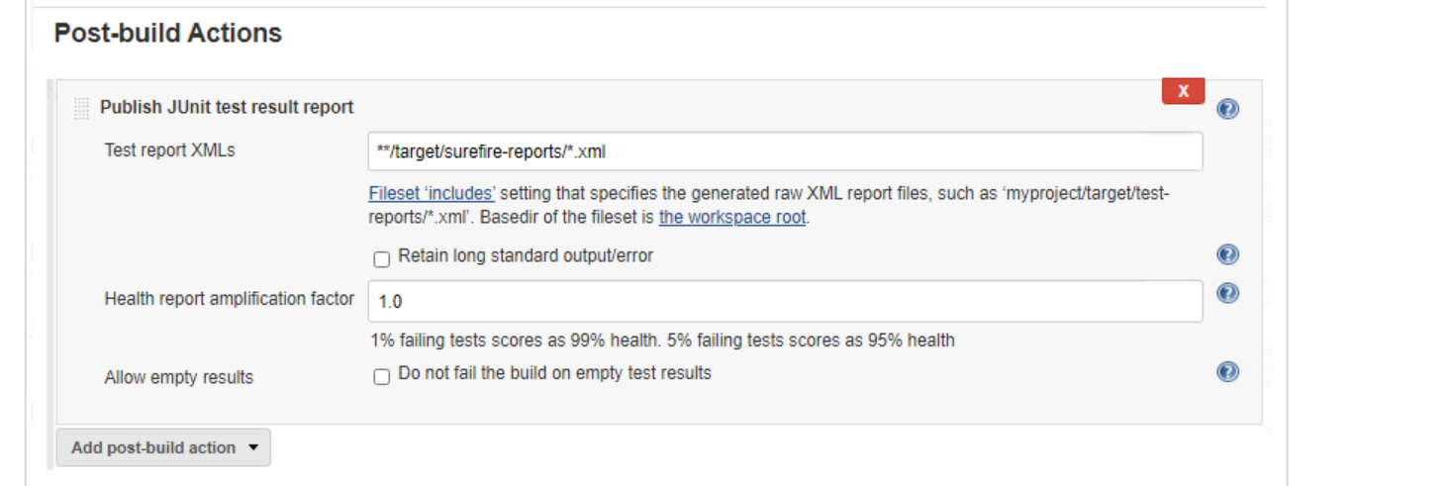

- Once completed, click on Save and Build the Job using “Build Now” option and see the results in console Output.

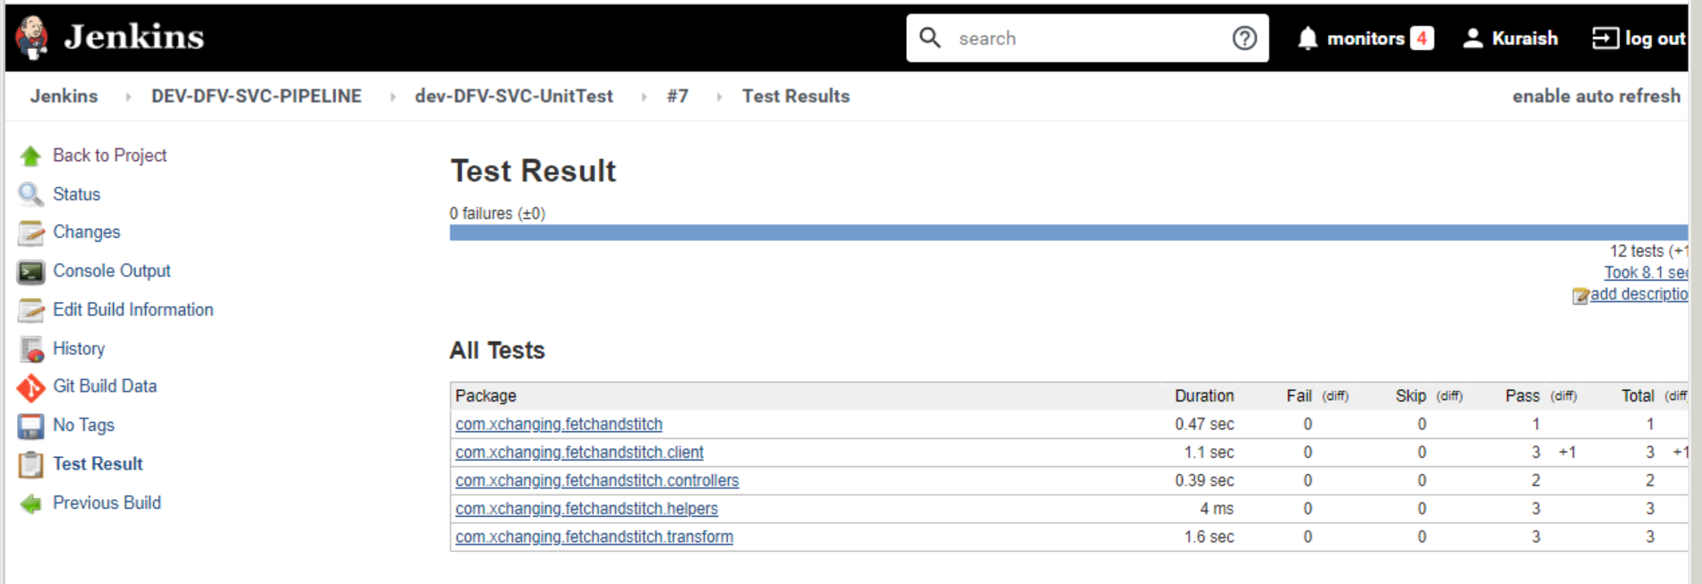

5.4 SonarQube Analysis Stage:

In this stage SonarQube will cheks for the code Quality and Scan the code based on our Conditions given in the QualityGate.
SonarQube have it's own default QualityGate.
But we are not using the Default QualityGate for SonarQube.
We have created our custom quality gate named as LM-QG.
The threshold points of our custom quality gate are as below:
1. maintainability Rating is worse than A (Code Smell)
2. Reliability Rating is worse than C (Bugs)
3. Security Rating is worse than A (Vulnerability)
If the code do not meet these conditions then QualityGate will fail and aborts the pipeline.
If the quality gate fails then Jenkins will automatically send the notification to the Developers.
If the quality gate passess then Jenkins will generate the SonarQube Report for us and Send these Reports to the respective people.

Steps to Create SonarQube Job in Jenkins:

You need to install plugin to do this job, we are using SonarQube Scanner Plugin to do it
Go to Manage Jenkins-> Manage Plugins-> under Available Search for “SonarQube Scanner Plugin” and click install without restart.
- Create New Item and select “Free Style Project”, Provide the name click OK
- In “General Section” Provide the description and select the checkbox if any details required else ignore
- Under “Source Code Management Section” Select the Git and provide the URL of your Code Repository.

- Under “Build Session” Select the “Execute SonarQube Scanner” and provide the Sonar analysis Properties.

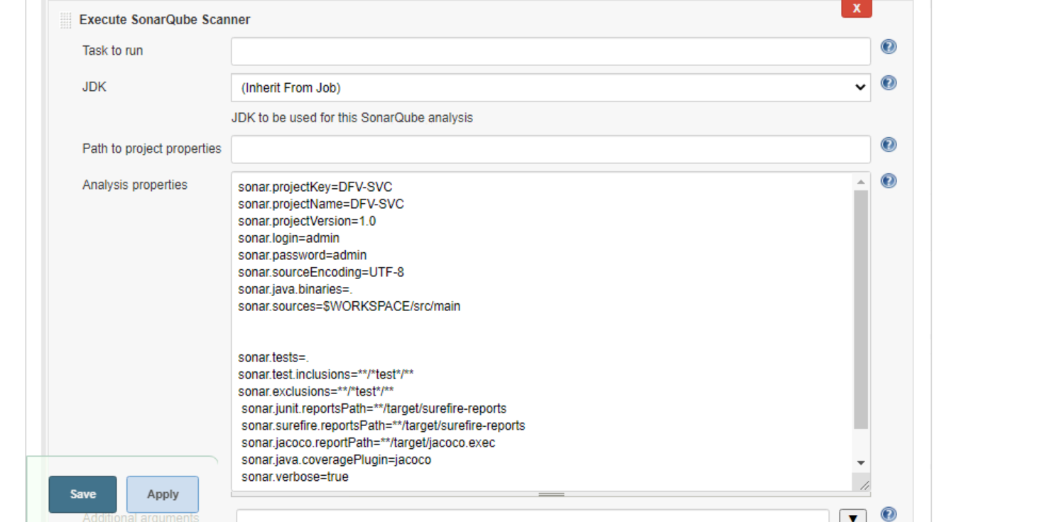

- To generate the Sonar Reports, we are using the below shell commands in the “Execute Shell” step in the Build Session.

# CURRENTEPOCTIME=`date +"%Y-%m-%d"`
# rm -rf DFV-SVC-sonar_reports*
# mkdir -p DFV-SVC-sonar_reports_${BUILD_ID}
# java -jar /data/lib/jenkins/sonar_lib/sonar-cnes-report-3.1.0.jar -p DFV-SVC -s http://10.16.26.51:9000/ -m -f -o DFV-SVC-sonar_reports_${BUILD_ID}/
# tar -czvf DFV-SVC-sonar_reports_${BUILD_ID}_${CURRENTEPOCTIME}.tgz DFV-SVC-sonar_reports_${BUILD_ID}

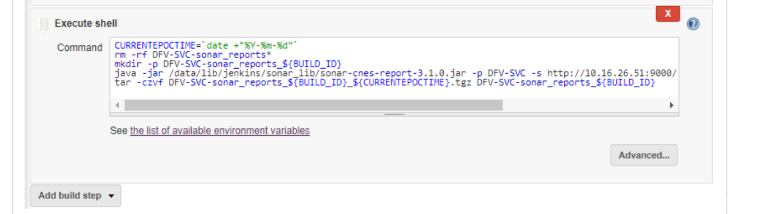

- Click on Save and trigger the job using “Build Now” Once job complete successfully you will see the below results in SonarQube Web Interface.

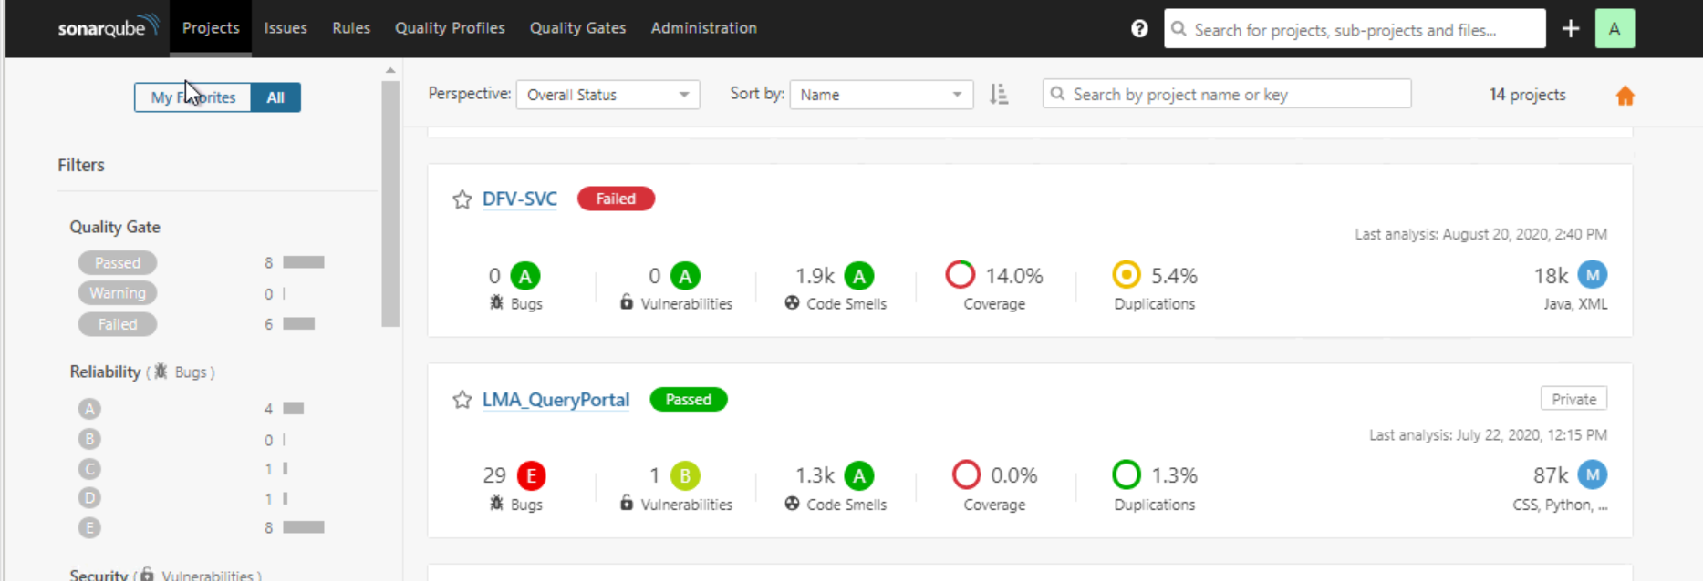

5.5 Build Stage:
This stage is for Building Packages/Artifacts for a given app by using Maven, Npm or MSBuild.
If this stage fails again Jenkins will abort the pipeline and sends the build failure notification to the respective team by attaching the build logs.

5.6 Deployment Stage:

In deployment we have two different kinds.
Up to Build stage the Pipeline is same for both Containerized Apps and Non-Containerized Apps.
Only Deployment Stage will differ for both the apps.

5.6.1 Containerized Apps:

All the containerized apps are deploying into the Kuberntes Platform.
In this we are going to use Dockerfile and K8s manifest files and these are placed in GitHub Repo itself.
Once after Building the package/artifact is completed then we are Building the Docker Image for the app by using Dockerfile and generated Package in Build stage.
Then Pushing the generated Docker Image to our JFROG Artifactory (lma-docker Repo).
Now we will be deploying our app into Kuberntes Cluster by using k8s Manifests directly from Jenkins.

Below are the steps for deployment.

1. 1.Create New Item and select “Free Style Project”, Provide the name click OK
2. In “General Section” Provide the description and select the checkbox if any details required else ignore
3. Under “Source Code Management Section” Select the Git and provide the URL of your Code Repository
4. Under “Build Session” Select the “Execute shell” and run the Shell Scripts “dockerbuild.sh” and “kubedeploy.sh” which come from the GitHub.
Using Git Commit as the Tag in the Docker Build command by using Variables.

dockerbuild.sh:
docker login ${DOCKER_REGISTRY_URL} -u ${DOCKER_USER} -p ${DOCKER_PASSWORD}
docker build -t ${DOCKER_IMAGE} .
docker build -t ${LATEST_TAG} .
docker push ${DOCKER_IMAGE}
docker push ${LATEST_TAG}
docker image remove ${DOCKER_IMAGE}
docker image remove ${LATEST_TAG}

kubedeploy.sh:
sed -i -e "s@$BASE_IMAGE_NAME@"$DOCKER_IMAGE"@g" ${K8s_DEPLOYMENT_FILE}

kubectl --kubeconfig ${QA_KUBE_CONFIG_PATH} apply -f ${K8s_DEPLOYMENT_FILE}

kubectl --kubeconfig ${QA_KUBE_CONFIG_PATH} apply -f ${K8s_DEPLOYMENT_SERVICE_FILE}

5.6.2 Non-Containerized Apps:

In the case of Non-Containerized apps once after building the package/artifact,
we are pushing and storing those artifacts in required repo in our JFROG Artifactory.
To deploy these non-containerized apps, we are configuring the required Windows server with Jenkins and
deploying the stored artifacts from JFROG to Windows IIS Server.

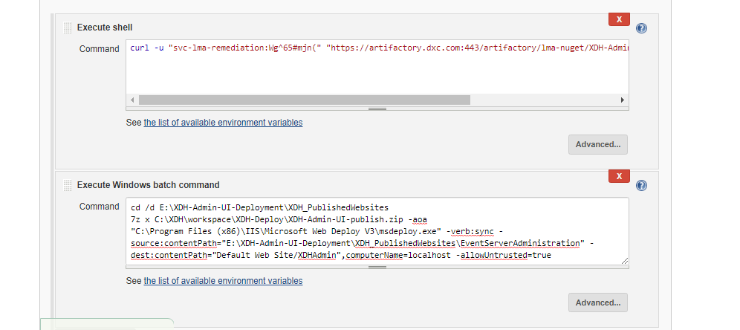

5.7 Build Pipeline Flow:

Once after creating all the Jobs for different stages, we are going to Chain them as Downstream Jobs and creating a New Pipeline View.
We are using Build Pipeline View Plugin to do it.
- Click on the "+" button on your Jenkins dashboard to create a New pipeline.
- Select Build a pipeline view under options and Name the pipeline and click Ok.
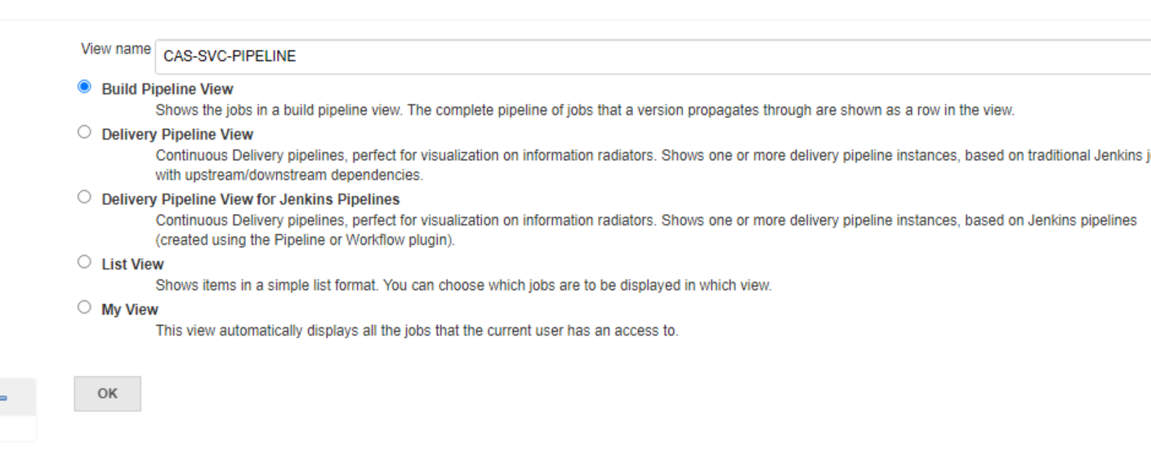
- In the next page, you will be asked for some more details to configure your Jenkins pipeline. Just accept the default settings, and make sure you choose the first job under the settings. Click on Apply and then OK.
- Now you can see your Pipeline as below.

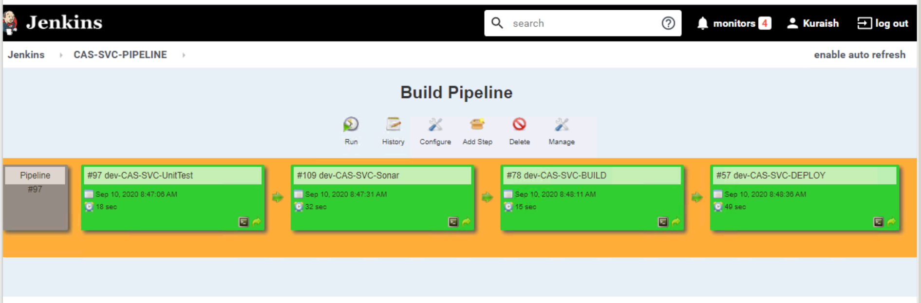
- If you want run/trigger you pipeline, you just need to click on “Run” option in the Pipeline View then it will run all our stages/jobs one by one.

5.8 Existing Pipelines:
Right now we are having 5 Critical apps already deployed in DEV and TSB/QA Environments by using these pipelines.
So, we are having separate pipelines in place for Dev and QA for all 5 apps.
Given some of the pipelines below.
DFV-SVC-PIPELINE: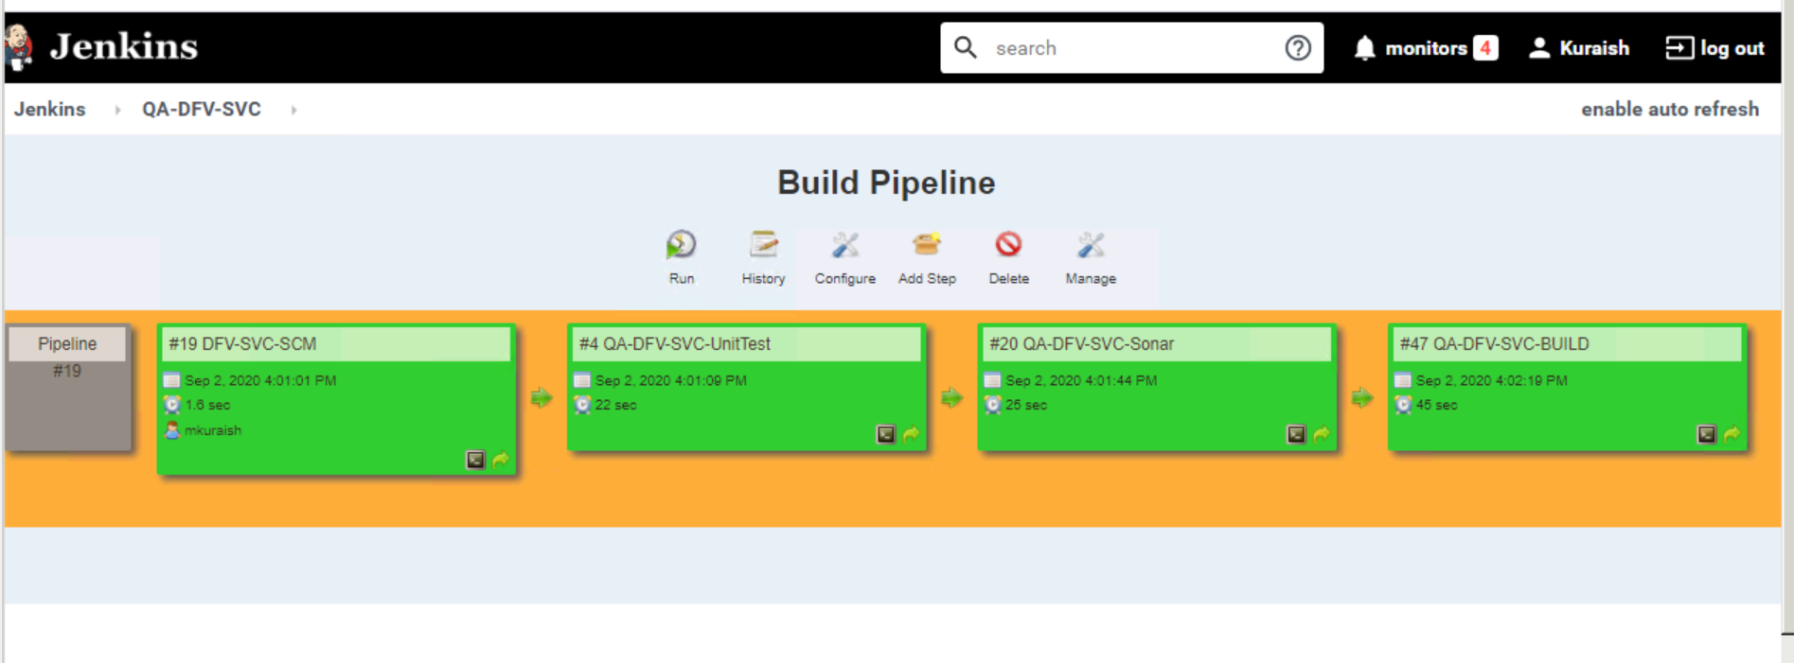
XMA-PIPELINE:
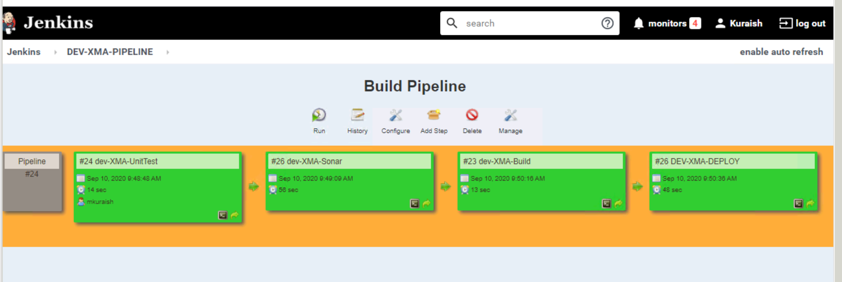

XDH-PIPELINE:
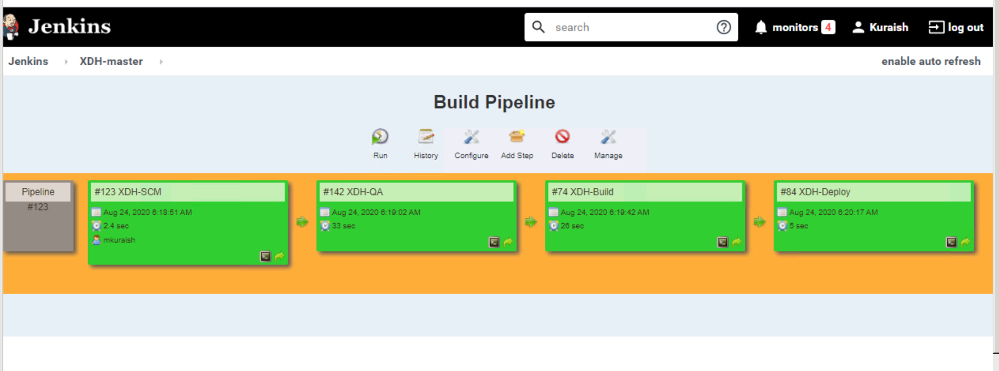

CI/CD Pipeline in Production Environment

Even for the Production Environment we will be having Similar strategy in CI/CD Pipeline.
We will be following Same stages for production pipeline also.
But we are having a Separate CI/CD pipeline which is specific to Production and this again contains all the stages which is like shown below.

7 Flowchart for CI/CD Pipeline Process of both Containerized and Non-Containerized Apps:

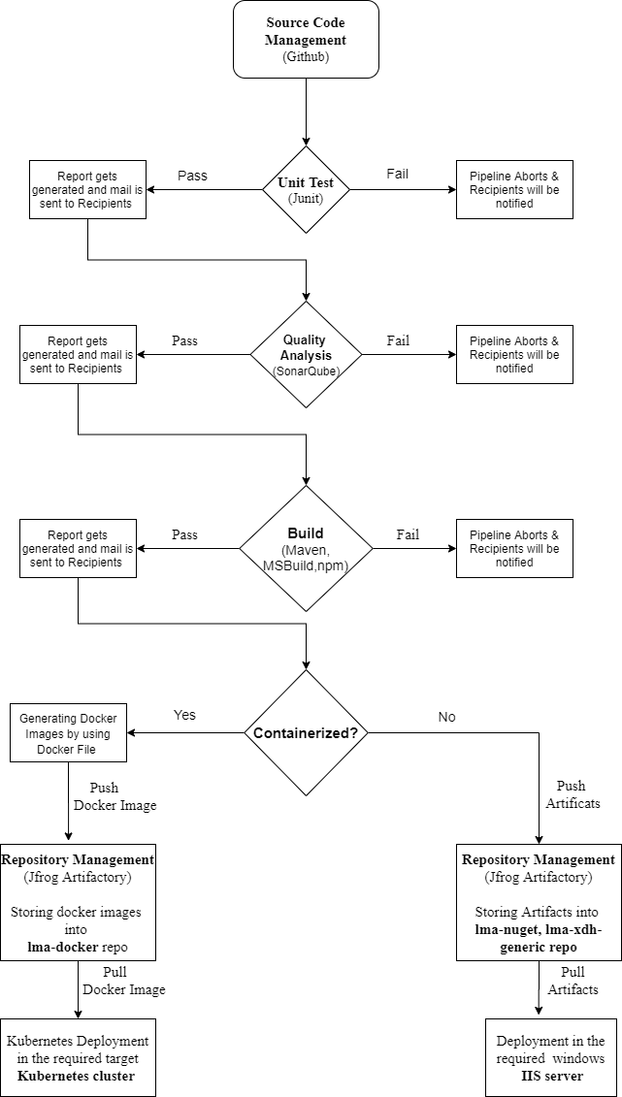

Pipeline as a Code Concept

8.1 Introduction:
Pipeline as Code describes a set of features that allow Jenkins users to define pipelined job processes with code,
stored and versioned in a source repository.

8.2 Jenkinsfile:
To use Pipeline as Code, projects must contain a file named “Jenkinsfile” in the repository root, which contains a "Pipeline script."

Right now in DG1 5 critical apps we don't have Pipeline as Code in place.
We have deployed those by normal Pipeline Plugins as explained above. Recently we have started to implement the pipeline Script for existing 5 apps.
We can use also Pipeline Script(Jenkinsfile) for the existing apps or else we can start this from next set of apps.

8.2.1 Sample Jenkinsfile:
We have implemented some sample Pipleline Scripts for existing apps.
Providing one of the Jenkinsfiles here.

def sendEmail()
{
mailRecipients = "snallabotul2@dxc.com, sivagami@dxc.com"
emailext body: '''Hello Team, We got the result for the pipeline "${JOB_NAME}", please find the logs in the attachment''',
mimeType: 'text/html',
attachLog: true,
subject: "${currentBuild.fullDisplayName} - Build ${currentBuild.result}",
to: "${mailRecipients}",
replyTo: "${mailRecipients}",
recipientProviders: [[$class: 'CulpritsRecipientProvider']]
}

pipeline {
agent {label 'master'}
environment {
SELENIUM_TESTING_PROJECT_WORKSPACE_PATH = "C:\DFV-selenium\Selenium_Test";
APPLICATION_NAME="dfv-svc-image";
K8s_DEPLOYMENT_FILE="dfv-svc-deployment.yaml";
K8s_DEPLOYMENT_SERVICE_FILE="dfv-svc-service.yaml";
BASE_IMAGE_NAME="${DOCKER_REPO_PATH}/${APPLICATION_NAME}";
DOCKER_IMAGE="${BASE_IMAGE_NAME}:${GIT_COMMIT}";
LATEST_TAG="${BASE_IMAGE_NAME}:latest";
DEV_KUBE_CONFIG_PATH = "/home/appadmin/.kube/dev_config";
QA_KUBE_CONFIG_PATH = "/home/appadmin/.kube/qa_config";
TSD_KUBE_CONFIG_PATH = "/home/appadmin/.kube/tsd_config";

}
stages {
stage('Unit Test - Junit') {
steps {
sh 'mvn clean test surefire-report:report'
}

post {
always {
junit '**/target/surefire-reports/*.xml'

}
success {
emailext attachLog: true,
mimeType: 'text/html',
attachmentsPattern: '**/*target/site/surefire-report.html',
body:'''UnintTest got success and report generated, please find the Report in the attachment.''',
subject:currentBuild.currentResult + " : " + env.JOB_NAME,
to: 'snallabotul2@dxc.com, sivagami@dxc.com'
}
}

}
stage('Sonar Qube - DFV-SVC') {
steps {
dir("${WORKSPACE}"){
script {
stage ('Static Code Analysis') {
withSonarQubeEnv('SonarQube') {
def sonarscanner_home = tool 'SonarScanner';
def SONARQUBE_URL = 'http://10.16.26.51:9000';
sh "${sonarscanner_home}/bin/sonar-scanner -X -Dsonar.host.url=${SONARQUBE_URL} -Dsonar.projectKey=DFV-SVC -Dsonar.login=admin -Dsonar.password=admin -Dsonar.projectVersion=1.0 -Dsonar.sources=$WORKSPACE/src/main -Dsonar.sourceEncoding=UTF-8 -Dsonar.java.binaries=. -Dsonar.exclusions=src/main/java/acord_repos_1_2_2/**/*,src/main/java/jvins_2013_06_dri_slice/**/*,src/main/java/com/xchanging/acord/extension/**/* -Dsonar.junit.reportsPath=**/target/surefire-reports -Dsonar.surefire.reportsPath=**/target/surefire-reports -Dsonar.jacoco.reportPath=**/target/jacoco.exec -Dsonar.java.coveragePlugin=jacoco"
}
}
stage('Quality Check') {
sleep(60);
timeout(time: 1, unit: 'MINUTES') { // If something goes wrong pipeline will be killed after a timeout
def qg = waitForQualityGate();
if (qg.status != "OK") {
currentBuild.result='FAILURE';
error "Pipeline aborted due to quality gate coverage failure: ${qg.status}"
}
else{
echo "Quality gate passed: ${qg.status}"
}
}
}

stage('Sonar Report Generation') {
sh label: '', script: '''#!/bin/bash
CURRENTEPOCTIME=`date +"%Y-%m-%d"`
rm -rf DFV-SVC-sonar_reports*
mkdir -p DFV-SVC-sonar_reports_${BUILD_ID}
java -jar /data/lib/jenkins/sonar_lib/sonar-cnes-report-3.1.0.jar -p DFV-SVC -s http://10.16.26.51:9000/ -m -f -o DFV-SVC-sonar_reports_${BUILD_ID}/
tar -czvf DFV-SVC-sonar_reports_${BUILD_ID}_${CURRENTEPOCTIME}.tgz DFV-SVC-sonar_reports_${BUILD_ID}'''
}
stage('Email Sonar Report') {
env.ForEmailPlugin = env.WORKSPACE
emailext mimeType: 'text/html',
attachLog: true,
attachmentsPattern: '**/*.tgz',
body:'''Hello Team, Code scan and code quality is done and report has generated. Please find the report in the attachment.''',
subject: currentBuild.currentResult + " : " + env.JOB_NAME,
to:'snallabotul2@dxc.com, sivagami@dxc.com'
}
}
}
}
}
stage('Building DFV-SVC App') {
steps {
sh '''mvn -s settings.xml clean install
sh extract-dependencies.sh '''
}
}
stage('Docker Build and Publish Image') {
steps {
sh '''cd $WORKSPACE

sh dockerbuild.sh
'''
}
}
stage('Deployment into k8s cluster') {
steps {
sh ''' cd $WORKSPACE
cd k8s

sed -i -e "s@$BASE_IMAGE_NAME@"$DOCKER_IMAGE"@g" ${K8s_DEPLOYMENT_FILE}

sed -i \'/nodeSelector/d\' dfv-svc-deployment.yaml
sed -i \'/k8s-lma01worker-11537310-2/d\' dfv-svc-deployment.yaml

kubectl --kubeconfig ${DEV_KUBE_CONFIG_PATH} apply -f .
'''
}
}
stage("Selenium Testing - DFV-SVC") {
agent {label 'DFVSeleniumNode'}
steps {
script{
stage ('Selenium Testing Checkout') {
dir("${SELENIUM_TESTING_PROJECT_WORKSPACE_PATH}"){
git (url: "https://github.dxc.com/rmishra28/AppRemediationFramework.git",
branch: 'master',
credentialsId: '6b4ee695-6673-4979-bbab-9b2075f576dc')
}
}
stage('Selenium Testing') {
dir("${SELENIUM_TESTING_PROJECT_WORKSPACE_PATH}"){
steps {
bat 'mvn clean test -DtestNGfile=src\\test\\resources\\testsuites\\dfv_smoke_testcases.xml'
}
}
}
}
}
}
}
post {
success {
sendEmail();
}

failure {
sendEmail();
}
}

}

Appendix

9.1 Reference Links
- https://www.jenkins.io/solutions/pipeline/
- https://devopscube.com/jenkins-pipeline-as-code/

